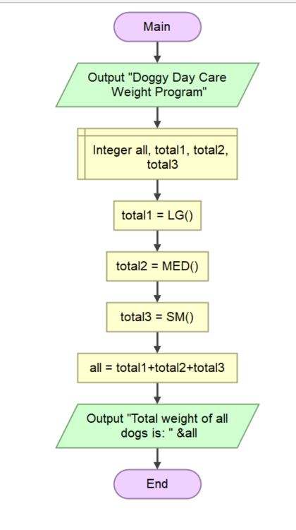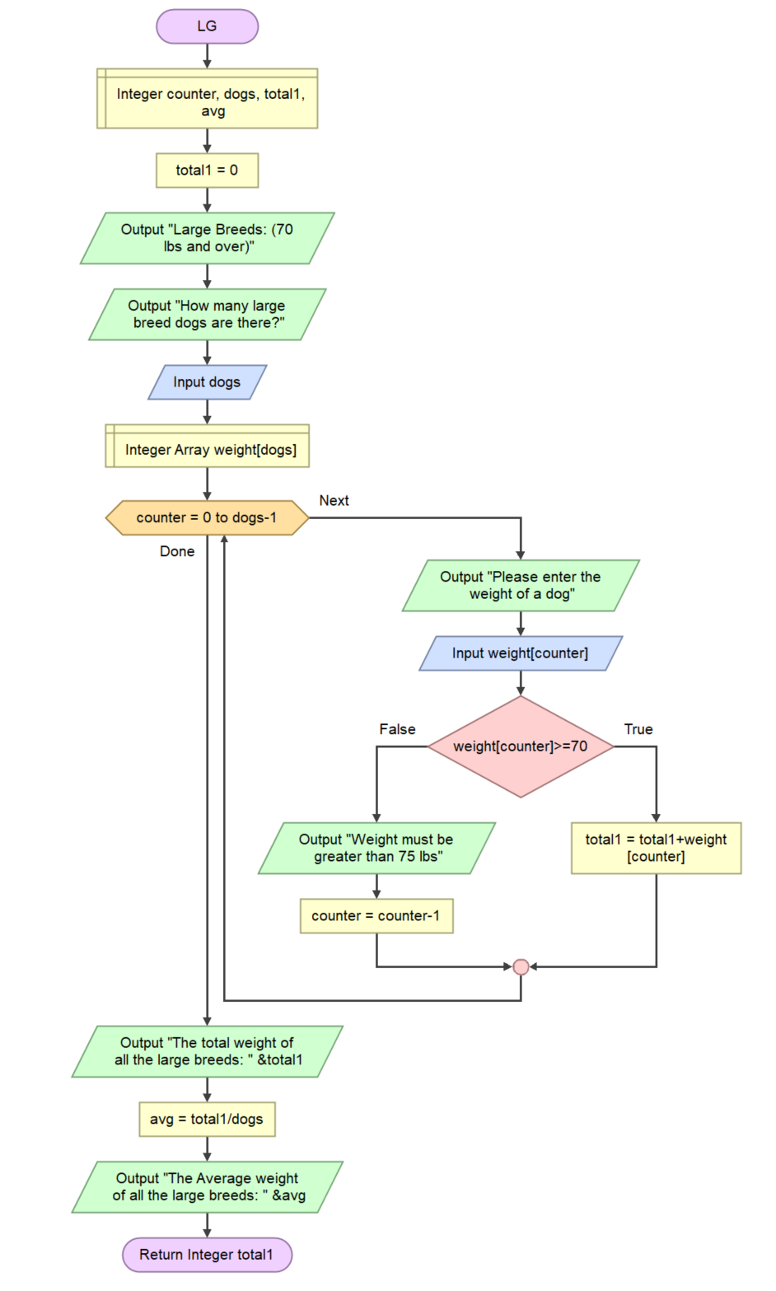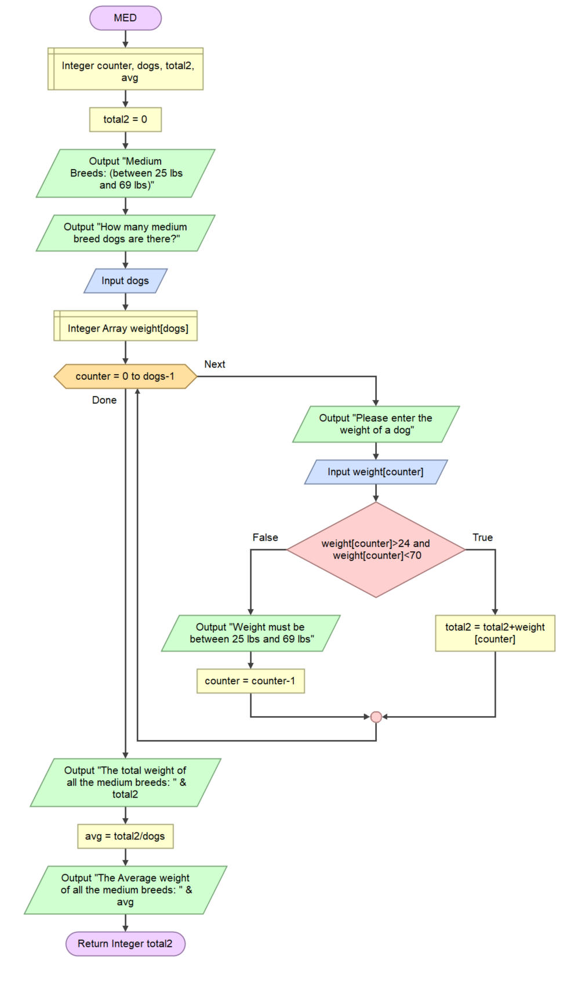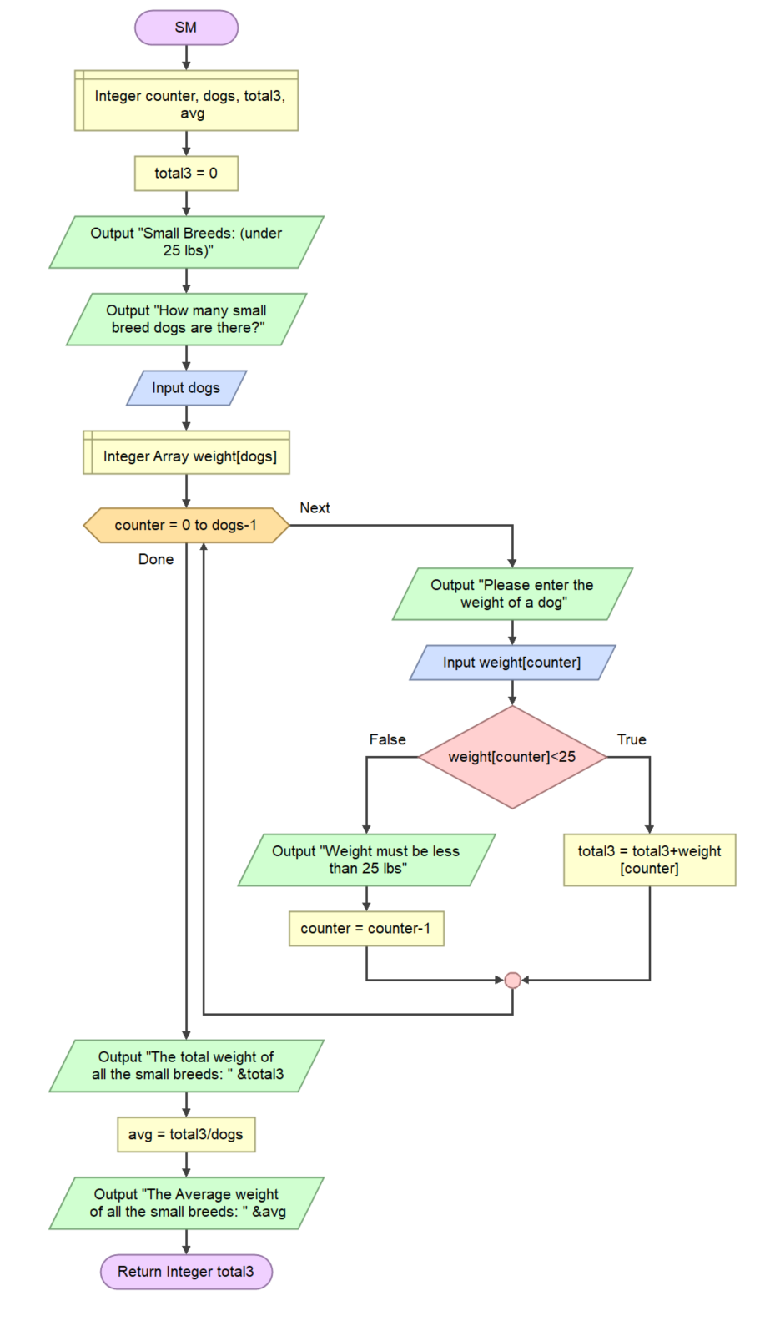

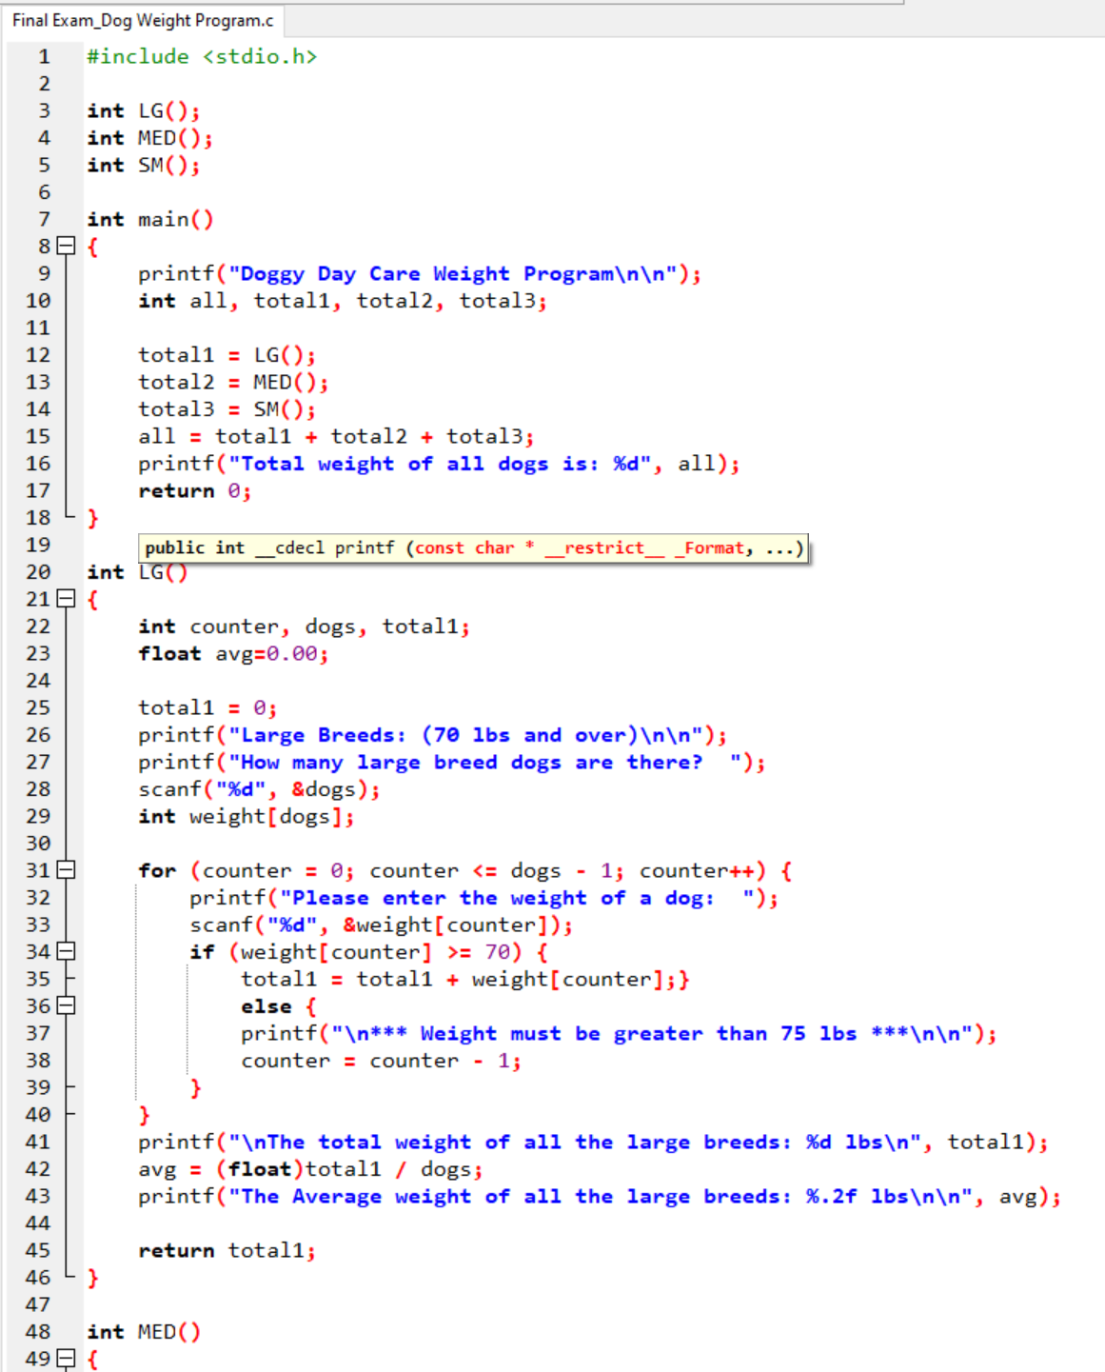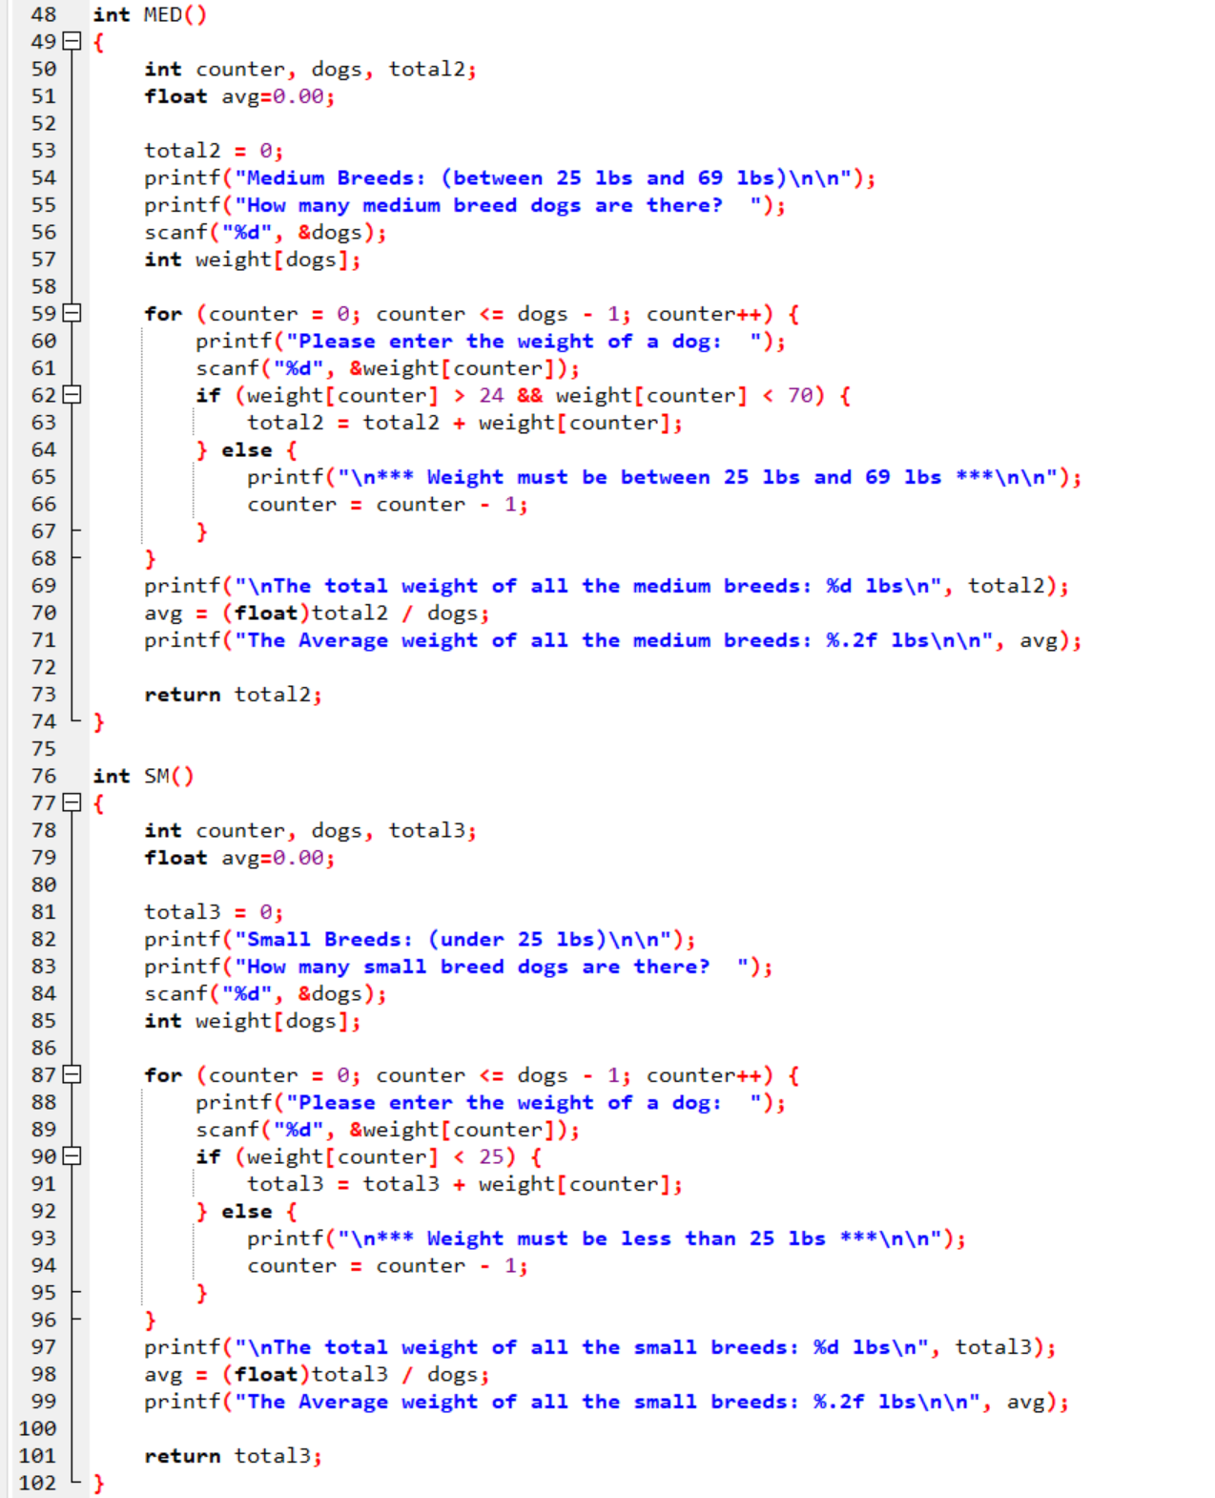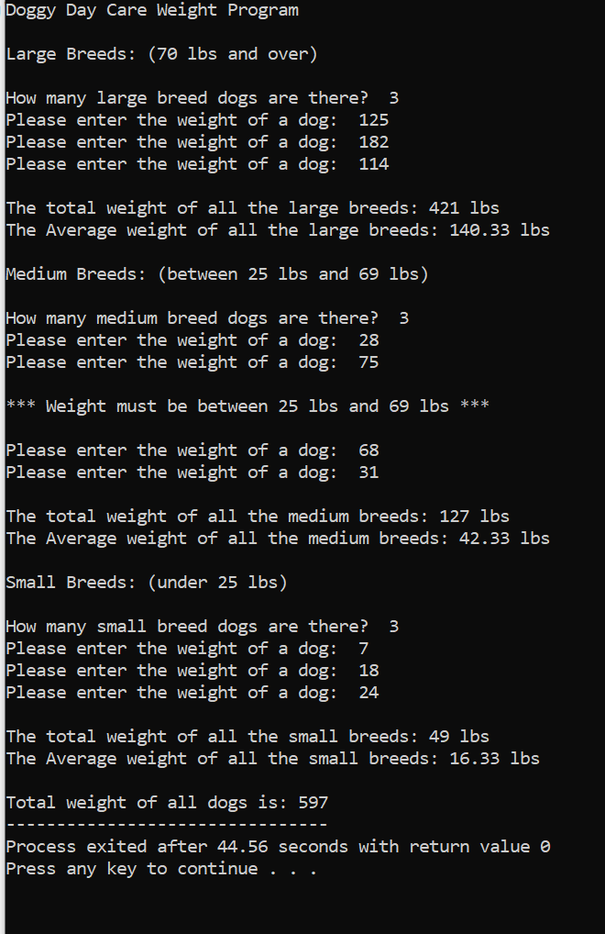

#include <stdio.h>

int LG();

int MED();

int SM();

int main()

{

printf("Doggy Day Care Weight Program\n\n");

int all, total1, total2, total3;

total1 = LG();

total2 = MED();

total3 = SM();

all = total1 + total2 + total3;

printf("Total weight of all dogs is: %d", all);

return 0;

}

int LG()

{

int counter, dogs, total1;

float avg=0.00;

total1 = 0;

printf("Large Breeds: (70 lbs and over)\n\n");

printf("How many large breed dogs are there? ");

scanf("%d", &dogs);

int weight[dogs];

for (counter = 0; counter <= dogs - 1; counter++) {

printf("Please enter the weight of a dog: ");

scanf("%d", &weight[counter]);

if (weight[counter] >= 70) {

total1 = total1 + weight[counter];}

else {

printf("\n\*\*\* Weight must be greater than 75 lbs \*\*\*\n\n");

counter = counter - 1;

}

}

printf("\nThe total weight of all the large breeds: %d lbs\n", total1);

avg = (float)total1 / dogs;

printf("The Average weight of all the large breeds: %.2f lbs\n\n", avg);

return total1;

}

int MED()

{

int counter, dogs, total2;

float avg=0.00;

total2 = 0;

printf("Medium Breeds: (between 25 lbs and 69 lbs)\n\n");

printf("How many medium breed dogs are there? ");

scanf("%d", &dogs);

int weight[dogs];

for (counter = 0; counter <= dogs - 1; counter++) {

printf("Please enter the weight of a dog: ");

scanf("%d", &weight[counter]);

if (weight[counter] > 24 && weight[counter] < 70) {

total2 = total2 + weight[counter];

} else {

printf("\n\*\*\* Weight must be between 25 lbs and 69 lbs \*\*\*\n\n");

counter = counter - 1;

}

}

printf("\nThe total weight of all the medium breeds: %d lbs\n", total2);

avg = (float)total2 / dogs;

printf("The Average weight of all the medium breeds: %.2f lbs\n\n", avg);

return total2;

}

int SM()

{

int counter, dogs, total3;

float avg=0.00;

total3 = 0;

printf("Small Breeds: (under 25 lbs)\n\n");

printf("How many small breed dogs are there? ");

scanf("%d", &dogs);

int weight[dogs];

for (counter = 0; counter <= dogs - 1; counter++) {

printf("Please enter the weight of a dog: ");

scanf("%d", &weight[counter]);

if (weight[counter] < 25) {

total3 = total3 + weight[counter];

} else {

printf("\n\*\*\* Weight must be less than 25 lbs \*\*\*\n\n");

counter = counter - 1;

}

}

printf("\nThe total weight of all the small breeds: %d lbs\n", total3);

avg = (float)total3 / dogs;

printf("The Average weight of all the small breeds: %.2f lbs\n\n", avg);

return total3;

}